**GUIDELINES FOR WASHINGTON STATE LAW ENFORCEMENT**

**Operation of License Plate Readers**

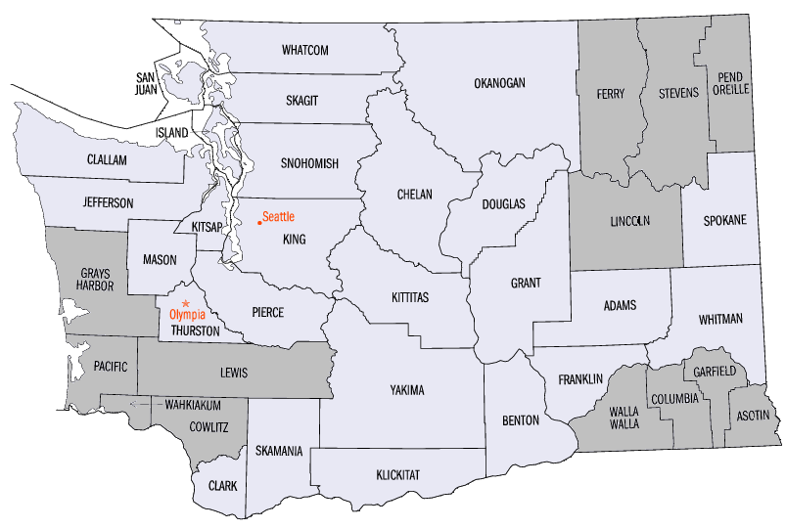

**WASHINGTON ASSOCIATION OF SHERIFFS AND POLICE CHIEFS**

May 2024

1. PURPOSE

The License Plate Reader Guidelines are adopted by the Washington Auto Theft Prevention Authority as a means of improving the operation and management of License Plate Reader equipment and data and facilitating compliance with applicable laws. LPR technology’s primary function is to convert data taken in the field from vehicle plates and use it to further public safety.

These Guidelines are based on legal requirements and the application of the experience of jurisdictions that have used Automated License Plate Readers. They are not intended as a substitute for professional judgment and common sense nor are they intended as legal authority or as legal advice. Counties, cities and agencies should involve their individual legal counsel in determining the answers to legal questions related to policy, procedure, and practice.

A model policy on the use of License Plate Readers is needed to provide guidance to agencies in the use of LPR technology. While LPRs enhance public safety by increasing law enforcement efficiency, public concerns regarding privacy implications of the technology should always be a consideration when employing this tool.

**II. GUIDELINES FOR LPR USE**

LPRs should only be used in accordance with applicable laws, in compliance with the agency-adopted policy and in furtherance of public safety. All users of LPRs should carefully consider community expectations for the use of LPRs and consult with their legal advisor when adopting or amending local LPR policy or procedures.

**OVERSIGHT**

The agency should designate a system administrator, consistent with WACIC guidelines, who is responsible for the following:

* Overseeing and administering the LPR program
* Manage the storage and maintenance of all LPR data including purging, retention and security
* Ensure documented training is completed prior to operator use of the system.
* Ensure that audits of system use and data storage are conducted.

**TRAINING**

* An Operator is prohibited from using the LPR system until properly trained in its use and in the agency’s policy.
* Operators must be ACCESS certified prior to accessing LPR data.

**LPR USAGE**

* + LPR operation and access to LPR collected data should be for official agency purposes

only.

* + The agency should document and maintain records of all LPR operators and their LPR usage.

**DATA COLLECTION AND RETENTION**

* All LPR data should be stored for a period not to exceed 90 days prior to purging. Data must be purged unless it is reasonable to believe it will become evidence in a criminal investigation; or if retained pursuant to Title 28 CFR (23). All LPR data should be subject to the same logging, handling and chain of custody requirements as other evidence.
* LPR data must be accessible only through a CJIS compliant authentication system which documents who accessed the information by identity, date and time.
* Access, or requests to review stored data, should be recorded and maintained in the same manner as any other local criminal justice information.

**AUDITING**

* Each agency should establish a regular auditing schedule of its LPR system to ensure compliance with applicable law and agency policy.
* Audits should be conducted at least annually.
* Audits should specifically examine, at a minimum:
  + LPR data security;
  + LPR data retention and destruction; and
  + Access to LPR data.